Subject: Male, 21 years old

Table 1 – Comparison of FEV%
Time Interval (s) | FEV  (p-p) | Vital Capacity  (from step 3) | FEV/VC  (calculate) | (FEV/VC) x 100  (calculate) |  | Typical values
0-1 | 1.2 | 3.3 | 0.36 | 36% | FEV₁ | 66-83%
0-2 | 2.0 | 3.3 | 0.60 | 60% | FEV₂ | 74-94%
0-3 | 2.4 | 3.3 | 0.73 | 73% | FEV₃ | 78-97%

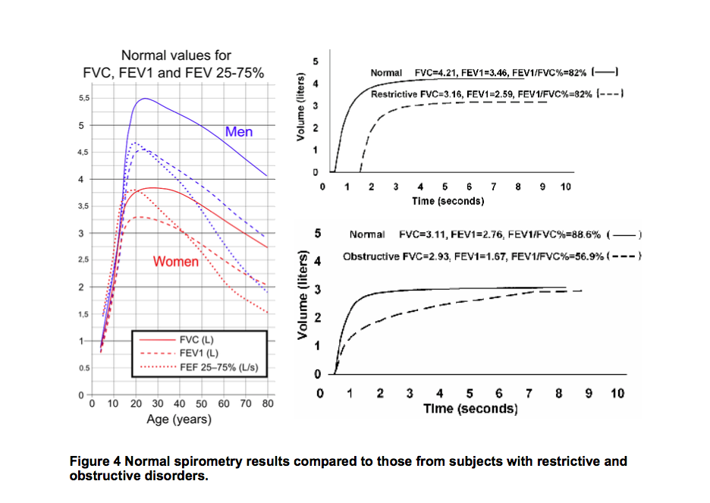

Table 2 – Comparison of Post-exercise FEV%
Time Interval (s) | FEV  (p-p) | Vital Capacity  (from step 3) | FEV/VC  (calculate) | (FEV/VC) x 100  (calculate) |  | Typical values
0-1 | 1.5 | 3.8 | 0.39 | 39% | FEV₁ | 66-83%
0-2 | 2.5 | 3.8 | 0.66 | 66% | FEV₂ | 74-94%
0-3 | 3.2 | 3.8 | 0.84 | 84% | FEV₃ | 78-97%

Table 3 – Volume of cycles
Cycle Number | p-p measurement (liters)
1 | 1.7
2 | 1.6
3 | 1.6
4 | 1.3
5 | 1.8
6 | 1.5
7 | 1.6
8 | 1.7
9 | 1.8
10 | 1.5
11 | 1.7
12 | 1.5
13
14
SUM = | 19.3
AVPC = | 1.6

Calculate the subject’s MVV by multiplying the subject’s RR (step 14) x AVPC (step 17). MVV = ____96_____ liters/min (MVV= RR x AVPC=60 x1.6=96)

Predicted MVV (L/min) = FEV1 x 35 = ___42___ (use the FEV1 p-p in liters, not %, that you entered in the first column and row of Table 1) (MVV (L/min) = FEV1 x 35=1.2 x 35=42)

